



MICROSOFT ARCHITECTURE BEST PRACTICE FOR SECURITY
USECASE: ENHANCED-SECURITY HYBRID MESSAGING INFRASTRUCTURE FOR WEB ACCESS
Document Title | ENHANCED-SECURITY HYBRID MESSAGING INFRASTRUCTURE FOR WEB ACCESS
Presales/Technical Head | Tushar Mehrotra/Rohit Pandey
CCoE Lead | Ravishankar N
Creation Date | March 2026
Version | Description | Modified by | Date | Approved by | Date
1 | Initial Architecture design | AJEET KUMAR | 11/03/2026 | Ravi Shankar | 11/03/2026
2 | Reusability & scalability | AJEET KUMAR | 17/03/2026 | Ravi Shankar | 17/03/2026
Contents
1
1. Executive Summary 3
2. Scope and Applicability 3
3. Business Scenario Overview 3
4. Reference Architecture Overview 3
4.1 Architecture Description 4
5. Logical Architecture Components 4
5.1 Identity and Authentication Layer 4
5.2 On-Premises Messaging Layer 4
5.3 Cloud Messaging Layer 5
5.4 Secure Web Access Layer 5
5.5 Perimeter and Access Proxy Layer 5
5.6 Monitoring and Governance Controls 5
6. Cloud Center of Excellence (CCoE) Enablement Model 5
7. Reusability and Scalability 5
9. Conclusion 6

1. Executive Summary
This document is based on secure hybrid messaging reference architecture for web access. The architecture enhances the security of web-based access to messaging services such as Outlook on the web and Exchange Admin Center in hybrid environments where mailboxes are hosted either on-premises or in Exchange Online.
The solution leverages Microsoft Entra ID, multifactor authentication (MFA), and secure access proxies to protect user authentication and web access without degrading user experience.

2. Scope and Applicability
This reference architecture applies to:
- Hybrid Exchange deployments (Exchange Online and Exchange on-premises)
- Web-based messaging access scenarios (Outlook on the web, ECP)
- Organizations requiring enhanced authentication security
- Federated and non-federated identity models
- Enterprise and CCoE-governed Microsoft 365 environments
The focus is on enhancing web access security for hybrid messaging platforms.

3. Business Scenario Overview
Organizations with hybrid messaging environments must allow users to securely access email and administrative portals via the web. Exposing these services without strong authentication controls increases the risk of:
- Credential compromise
- Unauthorized access
- Compliance violations
This architecture addresses these risks by enforcing Microsoft Entra multifactor authentication and controlled redirection flows for both cloud-hosted and on-premises mailboxes.

4. Reference Architecture Overview

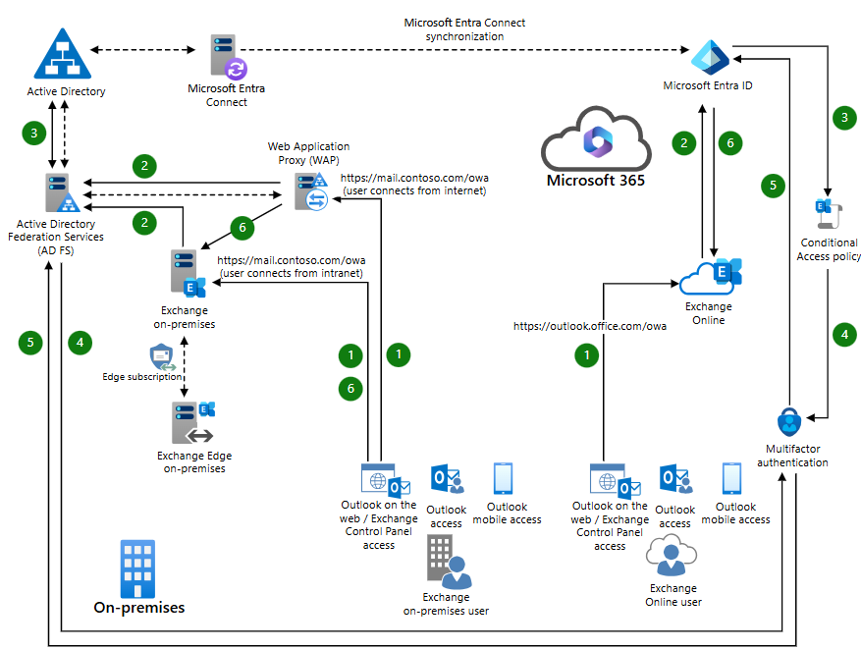

4.1 Architecture Description
The architecture separates secure access flows for:
- Exchange Online users accessing Outlook on the web
- Exchange on-premises users accessing web services through secure proxies
Authentication is centralized in Microsoft Entra ID, with optional federation through AD FS, while web traffic is securely published via reverse proxy components.

5. Logical Architecture Components

5.1 Identity and Authentication Layer
- Microsoft Entra ID for centralized authentication
- Microsoft Entra multifactor authentication (MFA)
- Microsoft Entra Connect for hybrid identity integration
This layer enforces strong identity verification across cloud and on-premises environments.

5.2 On-Premises Messaging Layer
- Exchange Server (Mailbox role)
- Optional Exchange Edge Transport servers
- Load-balanced Exchange infrastructure
This layer hosts on-premises mailboxes in hybrid or non-hybrid configurations.

5.3 Cloud Messaging Layer
- Exchange Online for cloud-hosted mailboxes
- Microsoft 365 web services
Cloud-hosted users are authenticated through Microsoft Entra ID before accessing web messaging services.

5.4 Secure Web Access Layer
- Outlook on the web (OWA)
- Exchange Admin Center (ECP/EAC)
- Enforced HTTPS web access
Web access is secured through centralized authentication and MFA enforcement.

5.5 Perimeter and Access Proxy Layer
- Web Application Proxy (WAP)
- AD FS (for federated identity scenarios)
- Reverse proxy and access control components
This layer protects on-premises web endpoints from direct internet exposure.

5.6 Monitoring and Governance Controls
- Authentication and access logging
- Centralized ing and compliance tracking
- Conditional Access policies
This ensures visibility and control over web access behavior.

6. Cloud Center of Excellence (CCoE) Enablement Model
The CCoE uses this architecture to:
- Define standard secure access patterns for hybrid messaging
- Govern identity and authentication configurations
- Ensure regulatory and security compliance
- Maintain consistency across hybrid environments

7. Reusability and Scalability
- Reusable for multiple hybrid Exchange deployments
- Scalable to large enterprise user populations
- Compatible with additional access scenarios (mobile and client access)

8. Conclusion
The Secure Hybrid Messaging – Web Access Reference Architecture provides a Microsoft-aligned approach for protecting web-based messaging access in hybrid environments. By combining Microsoft Entra ID, multifactor authentication, and secure access proxies, organizations can significantly strengthen their messaging security posture while preserving user experience.

